**Application of Visual Local Area Network (VLAN)**

Case Study (Philip John Pure water Factor).

**Name: Itobi Abiodun**

**Course: CompTIA N+**

**Aims And Objectives**

What is vlan

Important of vlan in Networking

Display the structural diagram of Vlan

Explaining Networking Tools

1. Ping
2. Ipconfig
3. Arp -a

Virtual LANs, also known as Virtual Local Area Networks, are logical groups of computers that appear to be on the same LAN regardless of how the underlying physical network is set up. Each VLAN is made up of a subset of ports on one or more switches or bridges, and network administrators divide the networks to fulfill the functional requirements of the VLANs.

**VLANs are used by network engineers for various purposes, such as the following:**

* To boost efficiency
* To boost security
* To make administration easier

**Explaining Networking Tools**

**PING**

A ping application, also known as packet internet or inter-network groper, is a simple Internet utility that lets users check if a specific destination IP address is reachable and capable of receiving requests for computer network management purposes.

**IPCONFIG**

On a Windows machine, you may see and modify the network settings using Ipconfig. It's frequently used to diagnose network problems, such as IP address errors or connectivity issues. The command can also be used to inspect a computer's current IP setup, showing the IP addresses assigned to each network adapter along with the DNS servers and default gateway.

**Address Resolution Protocol (ARP)**

Information at layer two is mapped to information at layer three using the Address Resolution Protocol (ARP). Ethernet is one instance of where we use this. One host has to know the destination MAC address—which is unknown—in order to send an IP packet to another host. All other computers then receive the ARP request that was broadcast by the initial host. In response, the host with the requested MAC address will send back an ARP reply with its MAC address.

**Implementation of Vlan in Philip and John Factory**

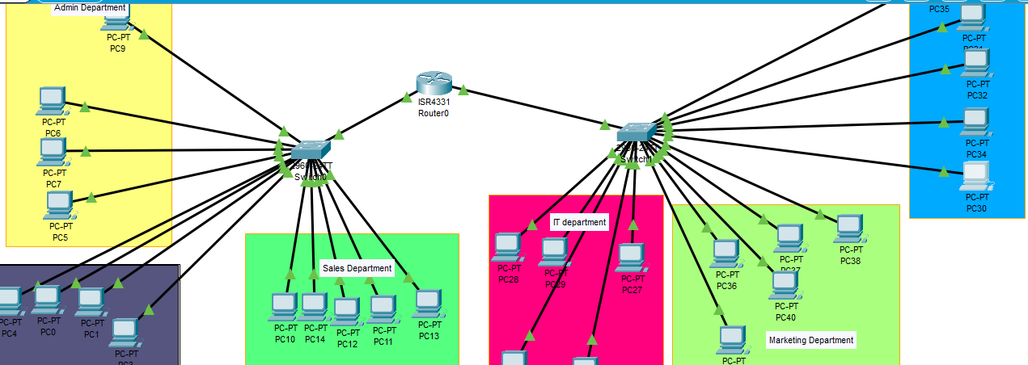

**Admin Department**

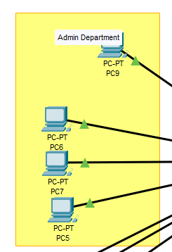

**1.1 Ping**

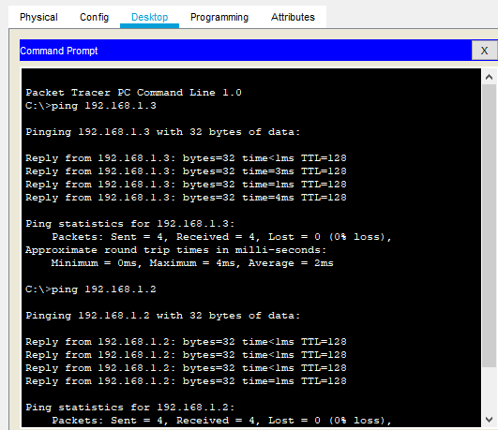

**1.2 Arp -a**

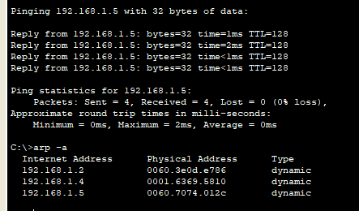

**1.3 IPCONFIG**

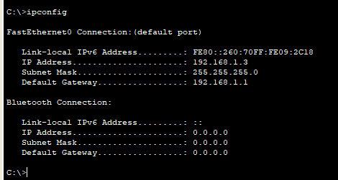

**SECURITY DEPARTMENT**

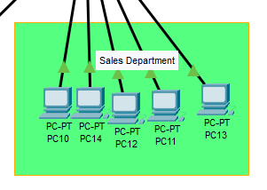

**2.1 Ping**

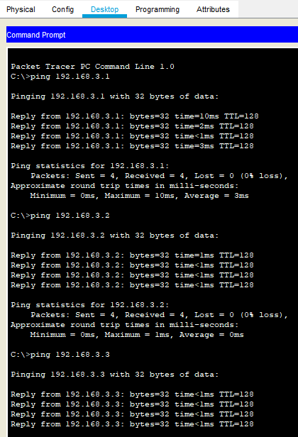

**2.2 ARP**

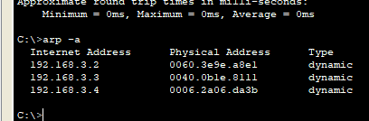

**2.3 Ipconfig**

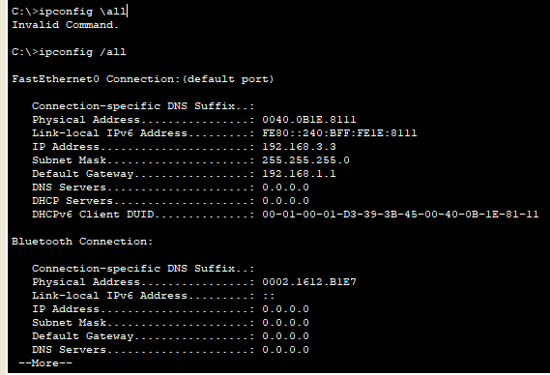

**Sales Department**

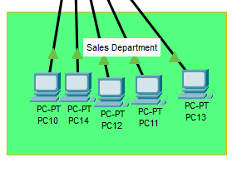

**3.1 PING**

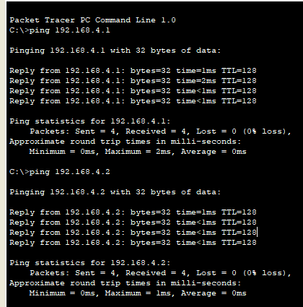

**3.2 ARP**

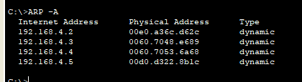

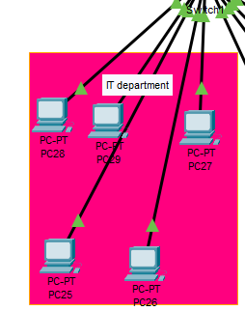

**4.1 PING**

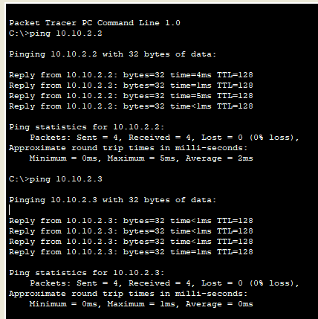

**4.2 ARP**

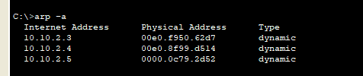

**4.3 IPCONFIG**

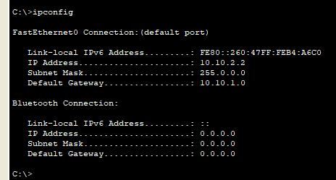

**Marketing Department**

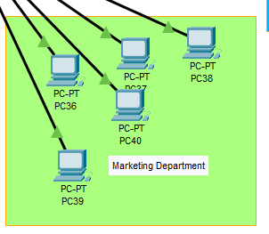

**5.1 Ping**

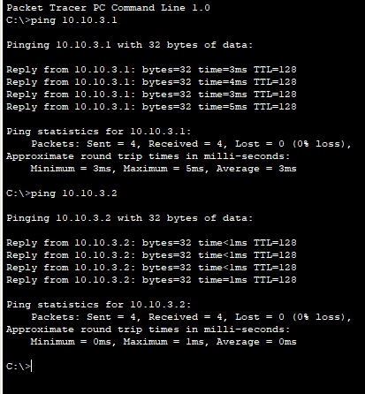

**5.2 APR**

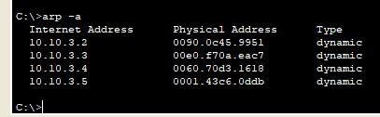

**5.3 Ipconfig**

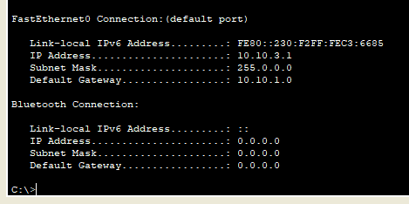

**Engineering Department**

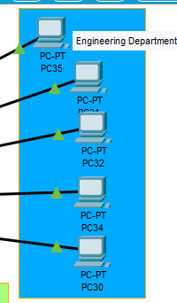

6.1 PING

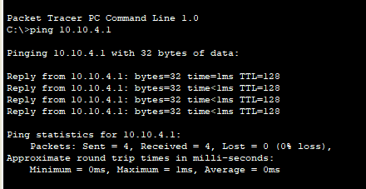

6.2 ARP

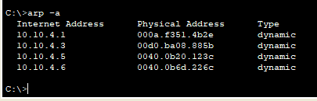

**6.3 IPCONFIG**

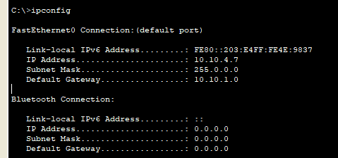

**CONFIGURATION FOR SWITCH ONE**

*Switch>en*

*Switch#conf t*

*Enter configuration commands, one per line. End with CNTL/Z.*

*Switch(config)#hostname S1*

*S1(config)#Vlan 10*

*S1(config-vlan)#interface f0/1*

*S1(config-if)#switchport access mode*

*^*

*% Invalid input detected at '^' marker.*

*S1(config-if)#switchport mode access*

*S1(config-if)#switchport access Vlan10*

*^*

*% Invalid input detected at '^' marker.*

*S1(config-if)#switchport access vlan10*

*^*

*% Invalid input detected at '^' marker.*

*S1(config-if)#switchport access Vlan10*

*^*

*% Invalid input detected at '^' marker.*

*S1(config-if)#switchport access Vlan10*

*^*

*% Invalid input detected at '^' marker.*

*S1(config-if)#vlan 10*

*S1(config-vlan)#interface f0/1*

*S1(config-if)#switchport mode access*

*S1(config-if)#switchport access Vlan10*

*^*

*% Invalid input detected at '^' marker.*

*S1(config-if)#switchport access vlan 10*

*S1(config-if)#interface f0/2*

*S1(config-if)#switchport mode access*

*S1(config-if)#switchport access vlan 10*

*S1(config-if)#interface f0/3*

*S1(config-if)#switchport mode access*

*S1(config-if)#switchport access vlan 10*

*S1(config-if)#interface f0/4*

*S1(config-if)#switchport mode access*

*S1(config-if)#switchport access vlan 10*

*S1(config-if)#interface f0/5*

*S1(config-if)#switchport mode access*

*S1(config-if)#switchport access vlan 10*

*S1(config-if)#exit*

*S1(config)#Vlan 20*

*S1(config-vlan)#interface f0/6*

*S1(config-if)#switchport mode access*

*S1(config-if)#switchport access vlan 20*

*S1(config-if)#interface f0/7*

*S1(config-if)#switchport mode access*

*S1(config-if)#switchport access vlan 20*

*S1(config-if)#interface f0/8*

*S1(config-if)#switchport mode access*

*S1(config-if)#switchport access vlan 20*

*S1(config-if)#interface f0/9*

*S1(config-if)#switchport mode access*

*S1(config-if)#switchport access vlan 20*

*S1(config-if)#interface f0/10*

*S1(config-if)#switchport mode access*

*S1(config-if)#switchport access vlan 20*

*S1(config-if)#exit*

*S1(config)#Vlan 30*

*S1(config-vlan)#interface f0/11*

*S1(config-if)#switchport mode access*

*S1(config-if)#switchport access vlan 20*

*S1(config-if)#switchport access vlan 30*

*S1(config-if)#interface f0/12*

*S1(config-if)#switchport mode access*

*S1(config-if)#switchport access vlan 30*

*S1(config-if)#interface f0/13*

*S1(config-if)#switchport mode access*

*S1(config-if)#switchport access vlan 30*

*S1(config-if)#interface f0/14*

*S1(config-if)#switchport mode access*

*S1(config-if)#switchport access vlan 30*

*S1(config-if)#interface f0/15*

*S1(config-if)#switchport mode access*

*S1(config-if)#switchport access vlan 30*

*S1(config-if)#exit*

*S1(config)#exit*

*S1#*

*%SYS-5-CONFIG_I: Configured from console by console*

**S1#show vlan**

**VLAN Name Status Ports**

---- -------------------------------- --------- -------------------------------

1 default active Fa0/16, Fa0/17, Fa0/18, Fa0/19

Fa0/20, Fa0/21, Fa0/22, Fa0/23 Fa0/24, Gig0/1, Gig0/2

10 VLAN10 active Fa0/1, Fa0/2, Fa0/3, Fa0/4 Fa0/5

20 VLAN20 active Fa0/6, Fa0/7, Fa0/8, Fa0/9 Fa0/10

30 VLAN30 active Fa0/11, Fa0/12, Fa0/13, Fa0/14 Fa0/15

1002 fddi-default active

1003 token-ring-default active

1004 fddinet-default active

1005 trnet-default active

VLAN Type SAID MTU Parent RingNo BridgeNo Stp BrdgMode Trans1 Trans2

---- ----- ---------- ----- ------ ------ -------- ---- -------- ------ ------

1 enet 100001 1500 - - - - - 0 0

10 enet 100010 1500 - - - - - 0 0

20 enet 100020 1500 - - - - - 0 0

--More—

**CONFOIGURATION OF SWITCH TWO**

*S1#conf t*

*Enter configuration commands, one per line. End with CNTL/Z.*

*S1(config)#hostname S2*

*S2(config)#Vlan 10*

*S2(config-vlan)#interface f0/1*

*S2(config-if)#switchport mode access*

*S2(config-if)#switchport access vlan 10*

*S2(config-if)#interface f0/2*

*S2(config-if)#switchport mode access*

*S2(config-if)#switchport access vlan 10*

*S2(config-if)#interface f0/3*

*S2(config-if)#switchport mode access*

*S2(config-if)#switchport access vlan 10*

*S2(config-if)#interface f0/4*

*S2(config-if)#switchport mode access*

*S2(config-if)#switchport access vlan 10*

*S2(config-if)#interface f0/5*

*S2(config-if)#switchport mode access*

*S2(config-if)#switchport access vlan 10*

*S2(config-if)#exit*

*S2(config)#Vlan 20*

*S2(config-vlan)#interface f0/6*

*S2(config-if)#switchport mode access*

*S2(config-if)#switchport access vlan 10*

*S2(config-if)#interface f0/7*

*S2(config-if)#switchport mode access*

*S2(config-if)#switchport access vlan 10*

*S2(config-if)#interface f0/6*

*S2(config-if)#switchport mode access*

*S2(config-if)#switchport access vlan 20*

*S2(config-if)#interface f0/7*

*S2(config-if)#switchport mode access*

*S2(config-if)#switchport access vlan 20*

*S2(config-if)#interface f0/8*

*S2(config-if)#switchport mode access*

*S2(config-if)#switchport access vlan 20*

*S2(config-if)#interface f0/9*

*S2(config-if)#switchport mode access*

*S2(config-if)#switchport access vlan 20*

*S2(config-if)#interface f0/10*

*S2(config-if)#switchport mode access*

*S2(config-if)#switchport access vlan 20*

*S2(config-if)#exit*

*S2(config)#vlan 30*

*S2(config-vlan)#interface f0/11*

*S2(config-if)#switchport mode access*

*S2(config-if)#switchport access vlan 30*

*S2(config-if)#interface f0/12*

*S2(config-if)#switchport mode access*

*S2(config-if)#switchport access vlan 30*

*S2(config-if)#interface f0/13*

*S2(config-if)#switchport mode access*

*S2(config-if)#switchport access vlan 30*

*S2(config-if)#interface f0/14*

*S2(config-if)#switchport mode access*

*S2(config-if)#switchport access vlan 30*

*S2(config-if)#interface f0/15*

*S2(config-if)#switchport mode access*

*S2(config-if)#switchport access vlan 30*

*S2(config-if)#exit*

*S2(config)#exit*

*S2#*

**%SYS-5-CONFIG_I: Configured from console by console**

**S2#show vlan**

**VLAN Name Status Ports**

**---- -------------------------------- --------- -------------------------------**

1 default active Fa0/16, Fa0/17, Fa0/18, Fa0/19

Fa0/20, Fa0/21, Fa0/22, Fa0/23

Fa0/24, Gig0/1, Gig0/2

10 VLAN0010 active Fa0/1, Fa0/2, Fa0/3, Fa0/4 Fa0/5

20 VLAN0020 active Fa0/6, Fa0/7, Fa0/8, Fa0/9 Fa0/10

30 VLAN0030 active Fa0/11, Fa0/12, Fa0/13, Fa0/14 Fa0/15

1002 fddi-default active

1003 token-ring-default active

1004 fddinet-default active

1005 trnet-default active

VLAN Type SAID MTU Parent RingNo BridgeNo Stp BrdgMode Trans1 Trans2

**---- ----- ---------- ----- ------ ------ -------- ---- -------- ------ ------**

**1 enet 100001 1500 - - - - - 0 0**

**10 enet 100010 1500 - - - - - 0 0**

**20 enet 100020 1500 - - - - - 0 0**

**--More--**